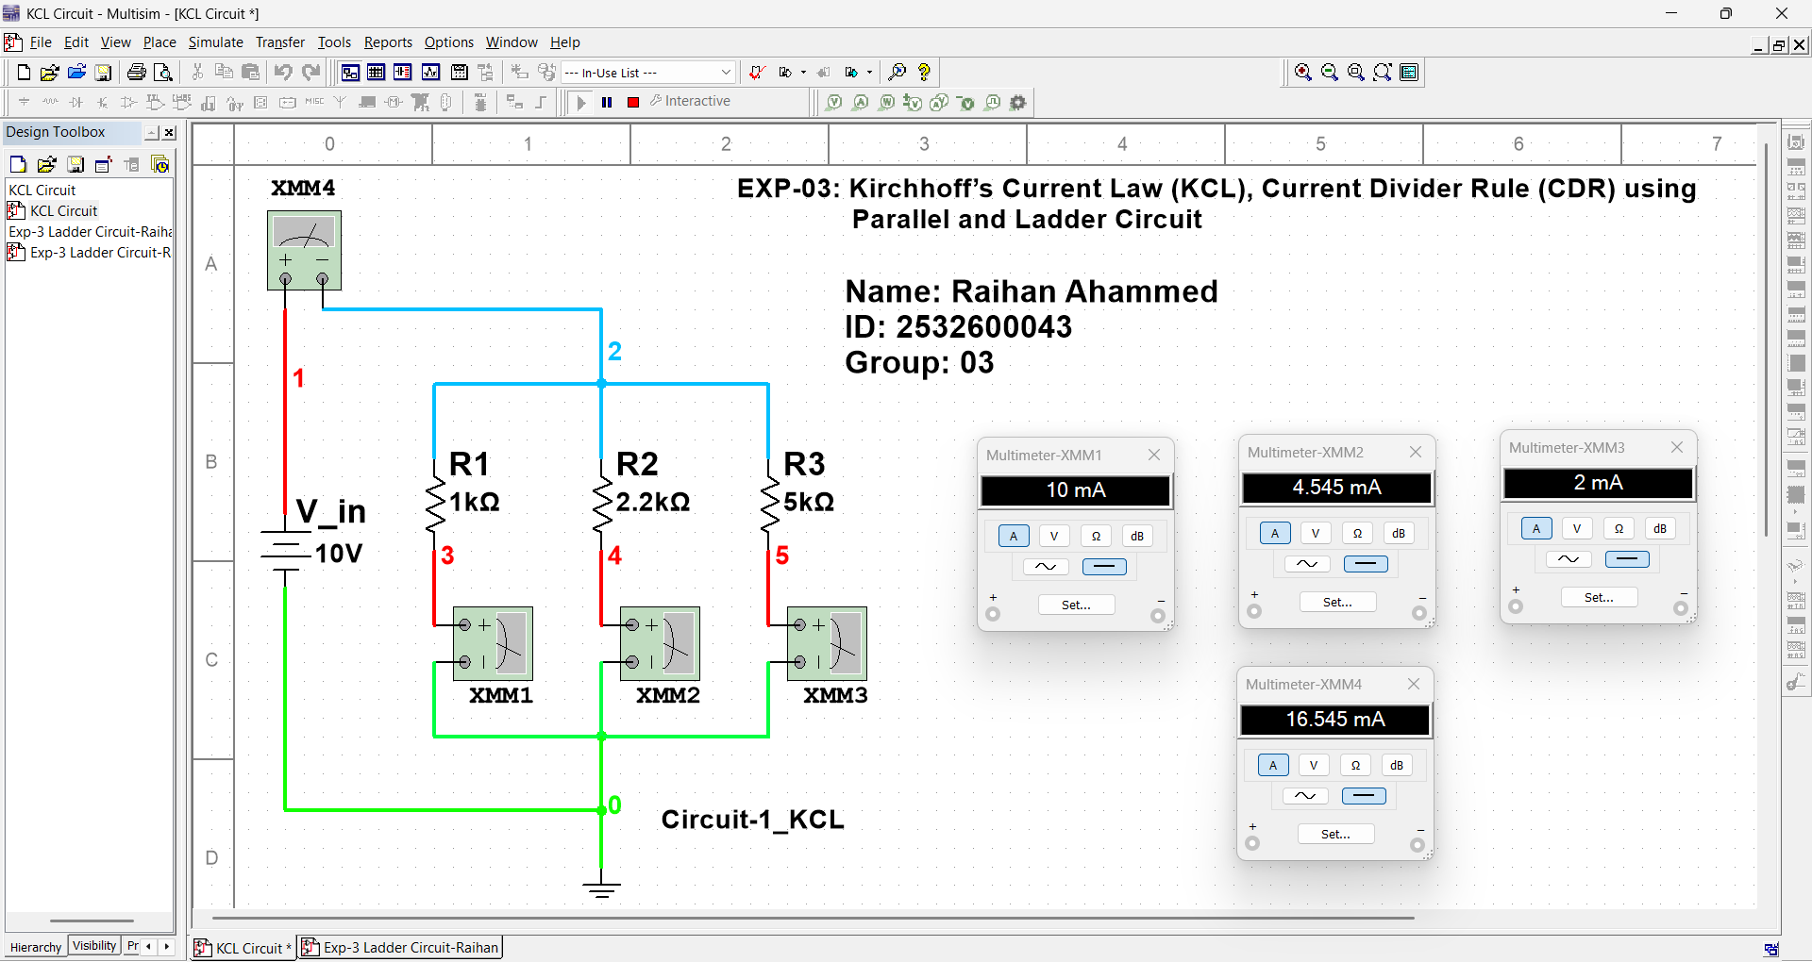
Exp-3: Kirchhoff’s Current Law (KCL), Current Divider Rule (CDR) using Parallel and Ladder Circuit
Name: Raihan Ahammed ID: 2532600043 Group: 03

